symbalooEDU
Go to the website: www.symbalooedu.com. The click on ‘Sign Up’
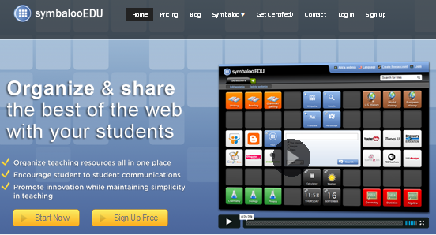
Once your account is created you will get the choice of ‘Quickstart’ or ‘Get Started’. Quickstart doesn’t give you the real idea of creating your very own web mix so choose ‘Get Started’
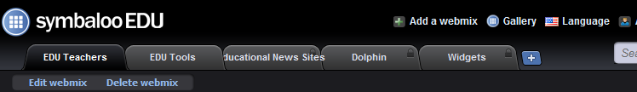
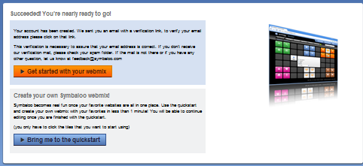

A web mix is a blank canvas of potential buttons that will be links to your favourite websites. You will have to give your web mix a name and this will depend on whether this is a personal web mix or a subject specific web mix. 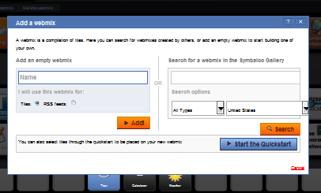
You now have a blank canvas to start working.
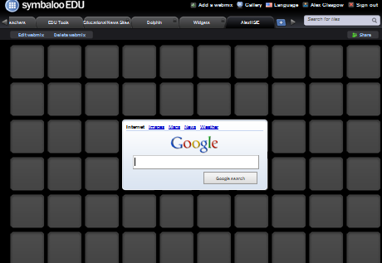
As you can search for web mixes, you can also search for individual tiles. Just check that the tile name matches the website you want. Simply type the name of the website you want in the search engine provided.

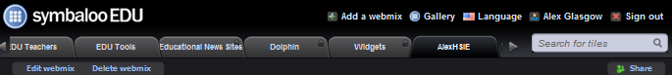

But it is much more fun to create your own tiles. Personalize them with images. Organize them on your web mix in like groups and colors and mix it up.
To create a tile simply click on a tile on your web mix and the following option will pop up.
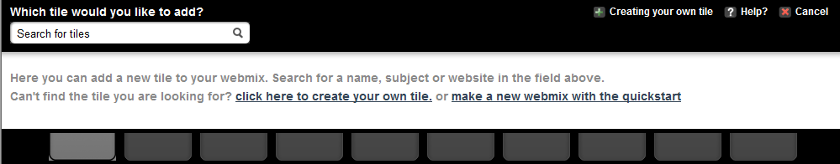
Again you can search for a tile or you can create your own tile by clicking this tab
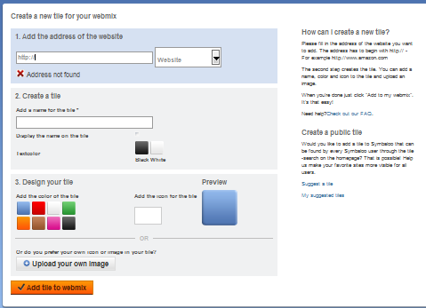
Complete the steps. You can add an icon supplied or you can use a saved jpeg image and upload to add to your tile. Once you have designed your tile, click on add tile to web mix.
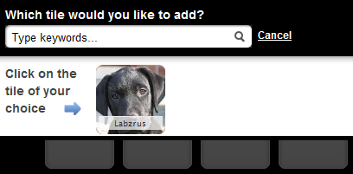
This will take you back to your web mix and your tile will appear on top tab. Now click on a blank tile location and then click on your designer tile and it will move to this location. This is not permanently locked in. You can later move tiles around as your web mix develops.
If you wish to get more creative you can add wallpaper or change your web mixes name by clicking on ‘edit’
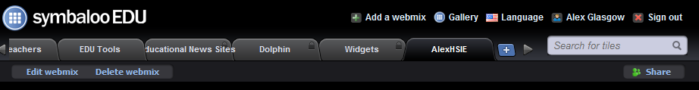

Your final task is to click on ‘Share’ this make your web mix public and give it a URL address. This allows you to access your web mix from any computer. You can also share your web mixes with your students. 